Course Project - What Will Visualization Do for Our Company?

Shaun Pritchard

Rasmussen College

QMB3000

Kevin Watts

May 10, 2020

**Course Project - What Will Visualization Do for Our Company?**

David, I am glad to see that you learn some information about the value of data visualization within XYZ Healthcare Company below I have outlined several platforms that may work best for your company moving forward. As well as some other information to help you facilitate an understanding of The Logical perspective data visualization in regard to XYZ Healthcare.

Data visualization is an essential process, but before implementing data visualization new technology has to be implemented, and there are a few requirements that must be implemented *(TRAN & GINIGE, 2019)* We would be glad to help you move forward with these task.

* Understand the data you are trying to visualize, including its size and cardinality (the uniqueness of data values in a column).
* Determine what you are trying to visualize and what kind of information you want to communicate.
* Know your audience and understand how it processes visual information.
* Use a visual that conveys the information in the best and simplest form for your audience.

**Here are some of the main attributes in which data visualization can move XYZ healthcare into the future as a data-driven company.**

**Data Visualization in healthcare:**

Healthcare companies and providers are poised to benefit tremendously from uncovering connections within their data. Rather than relying on time-intensive, costly, and limited data marts, medical professionals can analyze and uncover useful connections hidden within huge amounts of data *(Langkafel, 2016).*

**Pinpoint emerging trends to make predictions:**

Using data visualization to discover trends – both in the business and in the market – can give businesses an edge over the competition, and ultimately affect the bottom line. It’s easy to spot outliers that affect product quality or customer churn, and address issues before they become bigger problems.

**Identify relationships and patterns in business decisions:**

Even extensive amounts of complicated data start to make sense when presented graphically; businesses can recognize parameters that are highly correlated. Some of the correlations will be obvious, but others will not. Identifying those relationships helps organizations focus on areas most likely to influence their most important goals.

**Communicate the story to potential clients and shareholders:**

Once a business has uncovered new insights from visual analytics, the next step is to communicate those insights to others. Using charts, graphs or other visually impactful representations of data is important in this step because it’s engaging and gets the message across quickly.

**List of recommended data visualization technologies:**

This is a list of specific analytics platforms that I think would be a great fit for XYZ healthcare. With the implementation of previous proposals. XYZ Health Care needs the final crux to solidify a complete data-driven organization. here are my recommendations based on attributes, Technologies, features, and potential strengths and weaknesses.

The data that I have researched and allocated for you is pulled from Gartner magic quadrant BI(business intelligence) and analytics platforms 2020 report. I have recommended Tableau and SAS below.

**Gartner Magic Quadrant 2020**

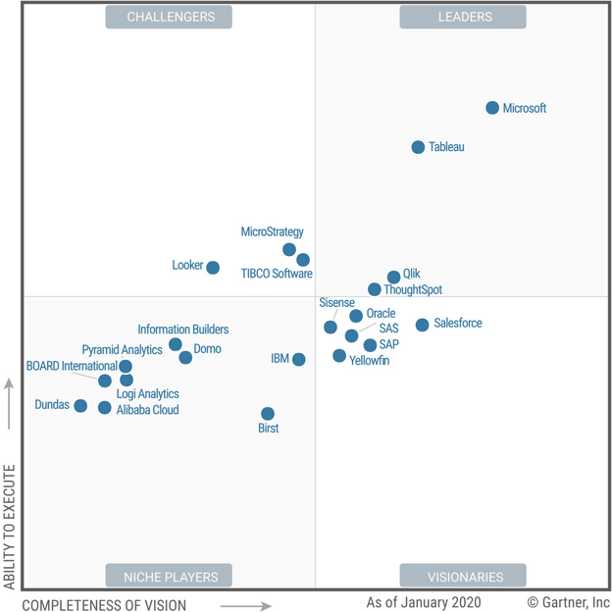

**Tableau**

Tableau is a Leader in this Magic Quadrant. It offers a visual-based exploration experience that enables business users to access, prepare, analyze, and present findings in their data. It has powerful marketing and expanded enterprise product capabilities, but there is some uncertainty about its direction as part of Salesforce.

In 2019, Tableau significantly broadened the scope of its product offerings, particularly their augmented analytics and governance capabilities. For augmented analytics, Tableau introduced both Ask Data and Explain Data to provide natural language query and automated insights. For governance, Tableau improved Tableau Prep Builder (which comes with Tableau Creator) and introduced Tableau Prep Conductor to schedule and monitor data management tasks. Tableau Prep Conductor comes bundled with Tableau Catalog as part of the Data Management Add-on. Tableau also introduced the Server Management Add-on, which provides server management, content migration and workload optimization. Tableau also moved a significant portion of its customer base to the cloud with Tableau Online.

**Strengths**

* **Customer enthusiasm:** Customers demonstrate a fanlike attitude toward Tableau, as evidenced by the more than 20,000 users who attended its 2019 annual user conference. Reference customers scored Tableau well above the average for the overall experience. These users serve as strong champions for Tableau.
* **Ease of visual exploration and data manipulation:** Tableau enables users to ingest data rapidly from a broad range of data sources, blend them, and visualize results using best practices in visual perception. Data can easily be manipulated during visualization, such as when creating groups, bins, and hierarchies.
* **Momentum:** Tableau grew its total revenue to just over $900 million through the first quarter of 2019 and achieved 14% growth from the first six months of 2018 to the first six months of 2019. Tableau remains a constant presence on evaluators’ shortlists and continues to expand within its installed base. The reference customers surveyed had mostly upgraded to Tableau’s latest version and expressed positive views about the migration experience.

**Weaknesses**

* **New risks in a changing market:**Tableau dominated the visual data discovery era of the ABI platform market, but as the market moves toward the augmented era, new entrants may prove disruptive. So far, however, Tableau has made sound choices in terms of balancing short-term and long-term product roadmap priorities.
* **Governance**: Despite new data and server management product releases that added governance and administrative capabilities in 2019, perceptions of weak governance and administration persist among some of Tableau’s reference customers. These are also evident during some Gartner inquiry calls.
* **Sales experience, contracting and cost:**Negotiating with Tableau has always had its pros and cons. In general, customers like Tableau Viewer as a lower-cost option for analytic consumers, and they are accommodating Tableau’s push toward subscription pricing. However, with the Server Management Add-on and Data Management Add-on, Tableau customers will be faced with a la carte pricing, which means they should expect to pay extra for new functionality (Gartner, 2020)*.*

**SAS**

SAS is a Visionary in this Magic Quadrant. This status reflects its robust product and global presence, as well as its challenges in terms of marketing and price perception.

SAS offers Visual Analytics on its new cloud-ready and microservices-based platform, SAS Viya. SAS Visual Analytics is one component of SAS’s end-to-end visual and augmented data preparation, ABI, data science, ML and AI solution.

In 2019, SAS significantly enhanced its augmented analytics capabilities. These now include automated suggestions for relevant factors, and insights and related measures expressed using visualizations and natural language explanations. They also include automated predictions with “what if?” and AI-driven data preparation suggestions. Additionally, SAS has enhanced Visual Analytics’ location intelligence capabilities and introduced a new SDK.

##### **Strengths**

* **End-to-end platform vision:** SAS’s compelling product vision is for customers to prepare their data, analyze it visually, and build, operationalize and manage data science, ML and AI models, in a single integrated, visual and augmented design experience (with progressive licensing). Moreover, with Visual Analytics, SAS is the only vendor in this Magic Quadrant to support text analytics natively.
* **Augmented analytics:** SAS is investing heavily in automation, with augmented analytics present across its entire platform. Investment areas include voice integration with personal digital assistants, chatbot integration and homegrown NLG, with outlier detection on the roadmap.
* **Global reach with industry solutions:** SAS is one of the largest privately held software vendors, with a physical presence in 47 countries and a global ecosystem of system integrators. Visual Analytics forms the foundation of most of SAS’s extensive portfolio of industry solutions, which includes predefined content, models, and workflows.

**Weaknesses**

* **Market perception:**AlthoughSAS now supports the open-source data science and ML ecosystem and has introduced a new SDK for SAS Visual Analytics, it was slow to respond to the open-source trend. This slowness has contributed to a market perception that SAS is expensive and proprietary, which has been a barrier to broader market consideration outside SAS’s installed base.
* **Sales experience:** Despite new capability-based and metered pricing options introduced in 2019, Gartner Peer Insights reviewers rate SAS comparatively poorly for pricing and contract flexibility. Moreover, a relatively high percentage of SAS Visual Analytics reference customers identified cost as a limitation to broader deployment in their organization.
* **Migration challenges:** SAS Viya represented a major redesign of the user experience and platform to create a more open environment. Although SAS has continued to improve its utilities to make migration easier, reference customers continued to view migration as challenging. SAS has also received relatively low scores and write-ups for product quality and support by reference customers and Gartner Peer Insights reviewers (Gartner, 2020)*.*

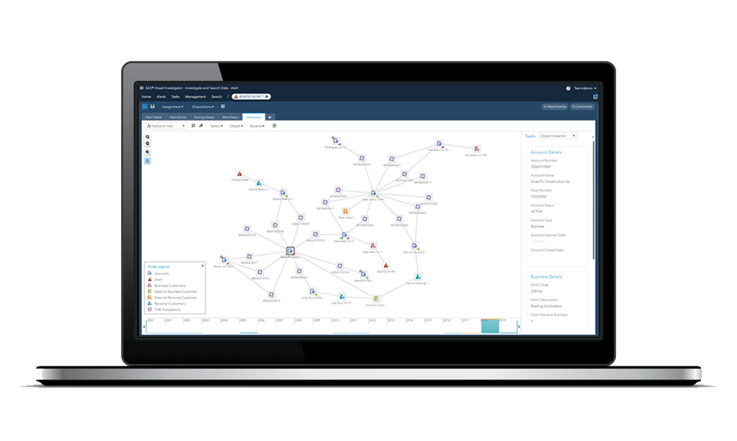

Both have almost the same features, but many professionals prefer SAS Visual Analytics over Tableau. Both are BI tools; they help you to come up with reports that comprise of data visualizations. Tableau is a self-service drag and drop tool. Which might be easier to implement for connecting new resources and companies starting with BI.

While SAS VA is not particularly harder but comparing to the performance SAS VA is more powerful technologically then Tableau. As SAS runs an LASR Analytic Server that processes things very fast gives you the required explorations or visualizations. The SAS LASR Analytic Server is an analytic platform that provides a secure, multi-user environment for concurrent access to data that is loaded into memory. LSAR Analytic Server is the heart of SAS VA tool as the cannot reside in place without the server. All the analytical processes are performed on the server rather than bringing the data to the tool and the processing on the data. Both have their own uses but surely SAS VA stands out of the two tools for more complex data needs. Ether tool is great and easy to use for both new and old companies with integrated BI needs.

I hope this information was helpful David for your company’s new data driven journey.

# References

Brownlee, J. (2019). *Machine Learning MAstery.* self.

Gartner. (2020). *Magic Quadrant for Analytics and Business Intelligence Platforms.* CA: Gartner.

Kirk, A. (2012). *Data Visualization A Successful Design Process.* USA: Packet.

Langkafel, P. (2016). *Big Data in Medical Science and Healthcare Management : Diagnosis, Therapy, Side Effects.* de Gruyter.

W., L. Y. (2006). Journey to Data Quality. *American Psychological Assoc*, 1.